* When the system gets started then the first process that it gets created is ‘init’ process
* Rest of the processes are its descendants or children
* Shell Program
  + A shell is an application program that runs programs on behalf of the user
  + Bash - default Linux shell
  + Sh - original Unix shell
  + csh/tsch - BSD Unix C shell

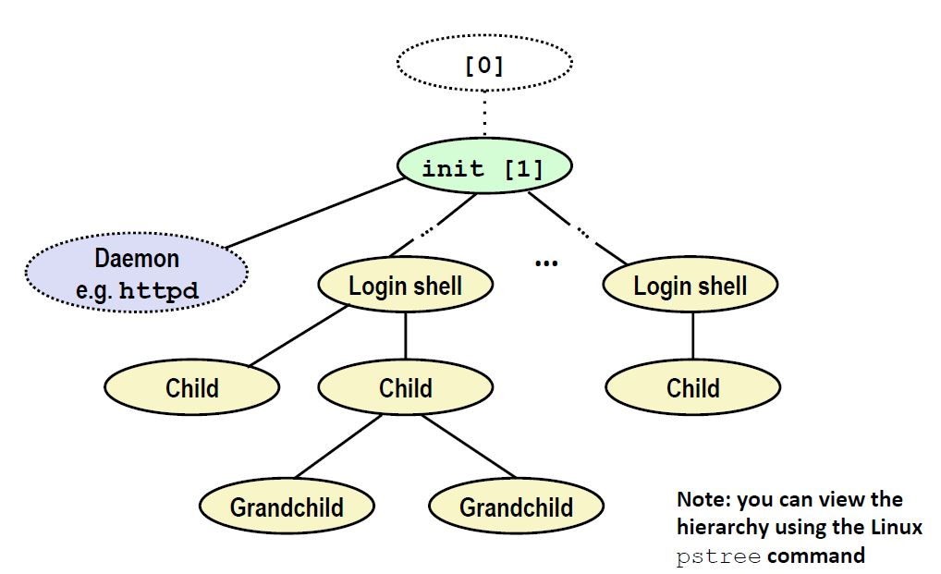

* The kernel will send a notification about it to shell called a signal